A Web-based Tool for Image Annotation
Reem K. Al-Halimi

Abstract
The image annotation tool is an online tool for labeling objects within RGBA images. The tool is based on the open source Js Segment Annotation Tool developed by Kota Yamaguchi [1]⁠. It is browser-based and compatible with a wide variety of platforms. The tool is designed for versatility and ease of use so users can efficiently label large numbers of cluttered images. This version intriduces several new features including the ability to label an image segment, or part of a segment, with multiple labels simultaneously, tracking object instances, labeling objects with disconnected visible parts, and efficiently storing the annotations and instance information in PNG files. The annotation process can be semi-automated by automatically segmenting the image into superpixels to allow for faster annotation of homogeneous segments.

Background
Computer vision systems have become significantly more efficient at tasks such as object detection, tracking, classification and segmentation among others (see, for example,[2]⁠ [3]⁠[4]⁠ and [5]⁠). Many of those systems utilize supervised learning techniques and train on large datasets of annotated images. As these datasets grow, however, annotating the images becomes increasingly more challenging and the efficiency of the annotation tool used becomes more essential. Unfortunately, very few annotation tools address this need for efficiency and versatility.
Our team at the Robotics Institute, University of Guelph, became acutely aware of this as we started creating the greenhouse plant dataset which will contain tens of thousands of images of greenhouse plants as part of the GIGAS project (ref?). The images are cluttered with many plants, stems, and fruits . Manually annotating those images is labor intensive and time consuming. Ideally, we would like the tool to have the following properties:
- Be easy to use so a large number of images can be annotated in a short amount of time.
- Be accessible online so users can access the tool in an office setting as well as a remote setting such as a greenhouse.
- Allow the user to accurately label disconnected objects as a single instance. For example, if a tomato fruit is partially hidden by a stem it will appear as a collection of disconnected parts. We would like our annotator to mark all visible parts of the tomato as belonging to the same instance of a single fruit without having to include the obstructing stem in the marked segments.
- Allow multiple labels to be applied to the same segment or part of a segment. So a leaf can be annotated as such, and any signs of disease on the leaf can also be labeled.
- Allows the user to keep track of different instances of the same object type. For example, all tomatoes in an image that has 10 tomatoes can be labeled as such, and each tomato object can be identified as a separate tomato instance as well.
- Efficiently store the resulting annotations and instance information, ideally in a single file.
Several annotation tools are currently available. Most annotators are desktop based with the exception of MIT’s LabelMe. LabelMe is a web-based tool created by the MIT team where users can help annotate pre-existing images, or upload their own images to annotate [6]⁠. Users can mark objects by a bounding box, either directly or through a masking tool, or by marking points to define the containing area. In the software descibed in this report, users can label objects using freeform curves or polygons. But for cluttered image such as that in Figure 1 the image tends to be dense with many objects. In this figure we can see numerous leaves, several stems, and many tomatoes. When tens of thousands such images need to be ground-truthed, the need for an efficient annotation tool becomes more pressing. For starters, some type of semi-automatic marking of the image segments may sometimes be helpful in speeding up the annotation process. Kota Yamagutchi et al’s Js-Segment-Annotator is another browser-based annotation software that also allows users to mark objects using a freeform polygon [1]. The interesting addition of this software, however, is that it provides a semi-automated way to segment the image into homogeneous superpixels which the annotator can then label with a single click.
The software presented in this report is based on the open source Js-Segment-Annotation tool. It builds on the original software’s tools and introduces several new features making it easier to use and providing more flexibility in labeling objects. In particular, our annotator allows for tracking and visualization of object instances, labeling disconnected objects, and multi-labeling any segment in an image. In what follows we describe each of these features in detail.
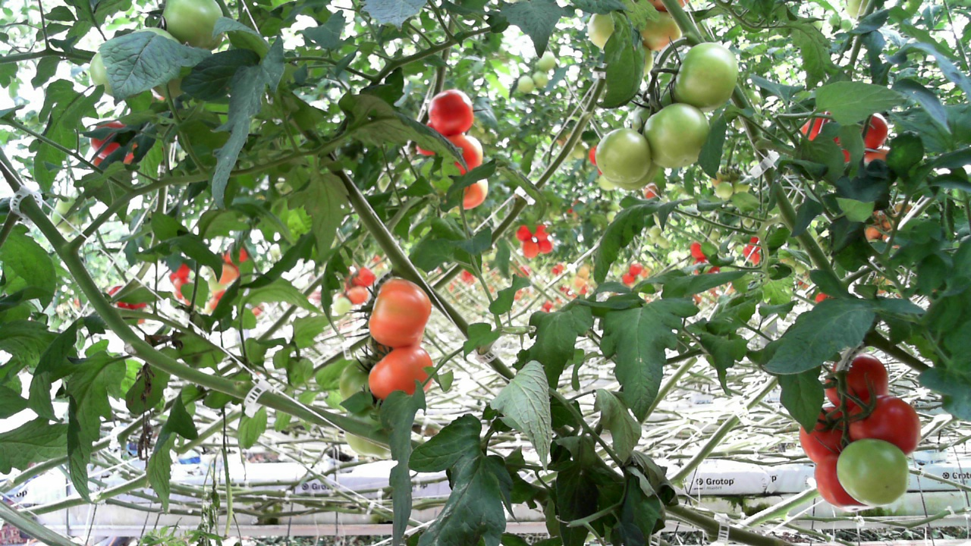
Illustration 1: An example of a plant image from a tomato greenhouse

Annotator Features

Efficient annotation process
The original version of the tool already included several useful tools to aid in speeding up the annotation including: a polygon tool to allow selecting a randomly shaped segment, a brush tool to simply label image pixels by running the cursor over them and a superpixel tool that automatically segments the image into homogeneous, randomly shaped areas.
The superpixel tool is particularly interesting as it automatically divides the image into homogeneous segments that can be used to annotate larger parts of the image more efficiently. The segment sizes generated by the superpixel tool can be adjusted to allow for the most efficient annotation given the shape and size of the object being labeled. Figure 1 illustrates the superpixel segments at two different sizes. Note how the smaller segments allow for labeling smaller segments, while larger superpixels encompass larger leaves or most of a tomato allowing a more efficient labeling process by simply selecting those segments. Segments can be quickly labeled and unlabeled by clicking the left and right mouse buttons. In addition, multiple tools can be used to mark the same object so flexibility and efficiency do not entail a compromise in accuracy.
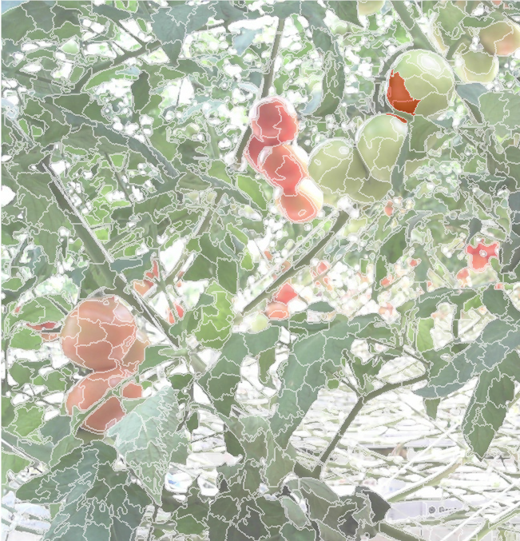 | 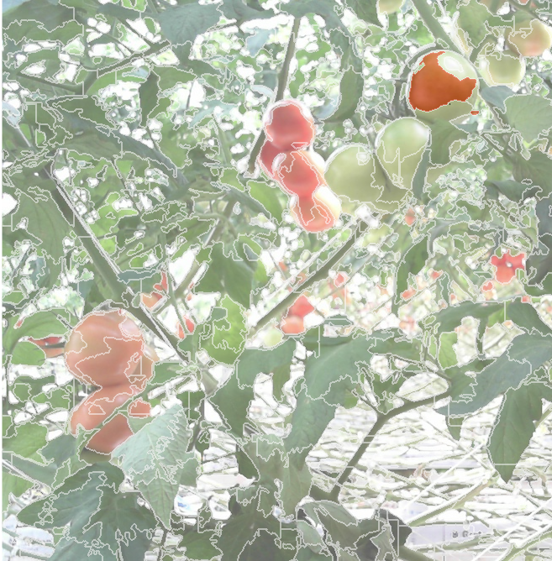
Figure 1: Different superpixel segment sizes allow us to cover more of an object with a single click for a more efficient annotation process.

Ability to label disconnected objects
The usual approach to annotating an object is to enclose it with a box or other closed shape. This is acceptable in cases where the object is fully visible. However, objects that are partially hidden by another object end up being labeled along with the other object as one instance. For example, in Figure ?? a car is hidden behind a tree trunk and some leaves. When using a closed shape to mark the boundaries of an image, users are forced to include at least some of the obstructing object in the enclosure. Figure ?? shows how the car had to be annotated along with the obstructing tree trunk and leaves in the polygon.

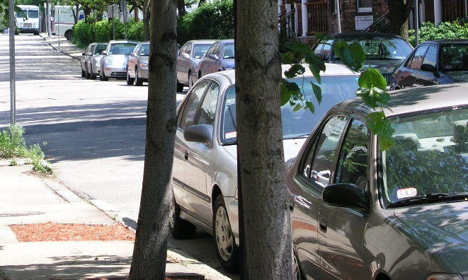  (a) | 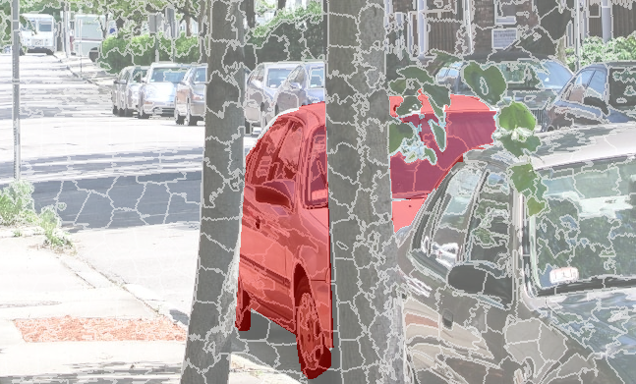 (b)
Figure 2: (a) Car obstructed by leaves and tree trunks. The car was labeled, along with the trunk, with a single polygon.(image source: image 1010736.jpg (partial), the Street Boston LabelMe database). (b) Car obstructed by leaves and tree trunks. Our tool was successfully used to label only the car segments. In this case we used both the polygon tool to mark the larger left most segment of the car, and the superpixel tool to mark the smaller segments hidden behind the leaves. The labeled areas are marked by the annotation tool indicating that they belong to a single instance.

Similarly, if a tomato fruit is partially hidden by stems or leaves, two or more disconnected parts of it will show. In our annotation tool, however, users can easily mark the disconnected parts of the object as belonging to the same instance. In Figure ?? above, for example, two large segments of the car and two smaller segments are visible. Each one of these segments has been labeled as a car and as being part of the same instance. For the small segments the superpixel tool was useful in labeling them with a single click. Obviously, no obstructing object was including in annotating this car instance.

Multi-label image segments
Sometimes the same segment belongs to two different labels simultaneously. For example, a leaf can be annotated as such, and any signs of disease on the leaf can also be labeled. This feature also allows parts of an object to be annotated as well. Figure 3 shows a whole tree labeled, then its trunk is also labeled as a trunk on the corresponding canvas. Both annotations will be encoded in the final annotations files allowing us to identify related objects and simultaneously label the same pixels according to different criteria.
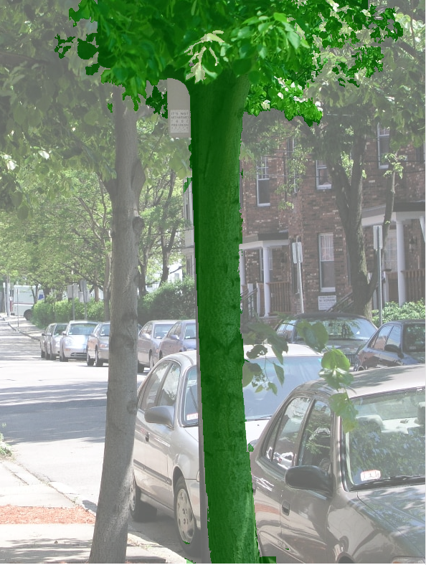  (a) | 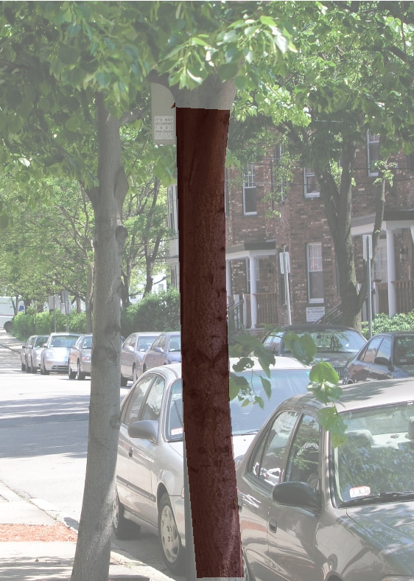  (b)
Figure 3: The same object, or part of an object, can be annotated with multiple images simultaneously. Here we label the whole tree with a label different from that of the trunk alone. Figures (a) and (b) show each annotation individually.

Track Object Instances
Annotated objects also have number along with its labels. These numbers allow the user to distinguish between different instances of the same object. For example, an image may contain 5 tomatoes. All tomatoes can be labeled as tomatoes and each individual tomato can be marked as an independent instance. Figure 4(a) shows the labeled tomatoes. All objects have the same color indicating the tomato label. But when we view them as instances (see Figure 4(b)), each object is shown in a different color based on its object number indicating that it belongs to a separate instance. Note how one tomato is partially hidden behind a stem. But its disconnected parts still have the same color indicating that all the parts belong to the a single instance.
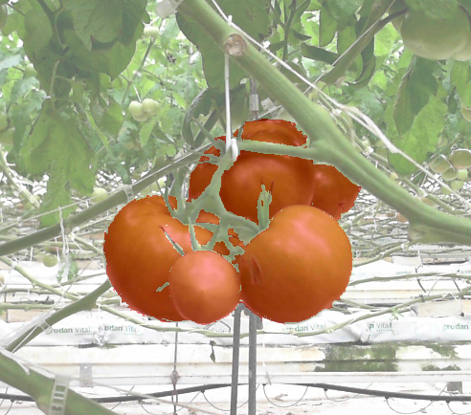  (a) | 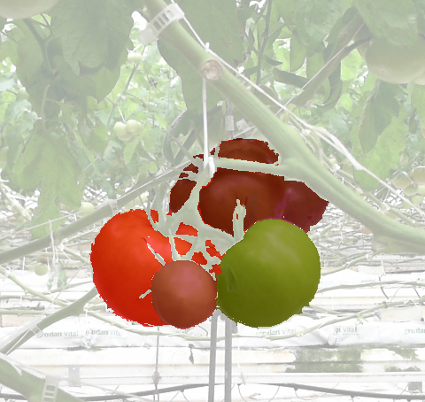  (b)
Figure 4:(a) A tomato clustered with all segments labeled as tomatoes colored in red. Note that two of the tomatoes in the image are green thus the slightly different shade of red. (b) The same labeled cluster showing which marked areas belong to the same tomato instance.

Online accessibility
Since this is a Javascript based tool, users can set up the software to be accessible from a website. This allows multiple users to annotate images in the database simultaneously.

Efficiently Store annotations
Each label is associated with its instance information in an annotation mask. The label and instance information are then superimposed on top of each other and combined in a single png file using a pairing function. The software package includes parsers to extract annotation information from these png annotation files.

Conclusion
In this report we present a browser-based open source annotation package that was designed to make annotating a large number of heavily cluttered images more efficient. The software features include:
- allowing users to annotate objects either using polygons or automatically created image segments/superpixels.
- Labeling image segments with any number of labels simultaneously.
- Tracking object instances.
- Annotated disconnected objects as a single instance such as the visible parts of a car hidden behind a tree trunk.
- Combining instance and annotation information using a pairing function and saving that information in a single PNG file.

References
[1] P. Tangseng, Z. Wu, and K. Yamaguchi, “Looking at Outfit to Parse Clothing,” 2017.
[2] K. He, X. Zhang, S. Ren, and J. Sun, “Delving Deep into Rectifiers: Surpassing Human-Level Performance on ImageNet Classification,” in The IEEE International Conference on Computer Vision (ICCV), 2015.
[3] A. Krizhevsky, I. Sutskever, and G. E. Hinton, “ImageNet Classification with Deep Convolutional Neural Networks,” in Advances in Neural Information Processing Systems 25, F. Pereira, C. J. C. Burges, L. Bottou, and K. Q. Weinberger, Eds. Curran Associates, Inc., 2012, pp. 1097–1105.
[4] L.-C. Chen, G. Papandreou, I. Kokkinos, K. Murphy, and A. L. Yuille, “DeepLab: Semantic Image Segmentation with Deep Convolutional Nets, Atrous Convolution, and Fully Connected CRFs.”
[5] P. Kontschieder, M. Fiterau, A. Criminisi, S. Rotabuì O, and F. B. Kessler, “Deep Neural Decision Forests,” in The IEEE International Conference on Computer Vision (ICCV), 2015.
[6] B. C. Russell, A. Torralba, K. P. Murphy, and W. T. Freeman, “LabelMe: a database and web-based tool for image annotation,” Int. J. Comput. Vis., vol. 77, no. 3, pp. 157–173, 2008.

